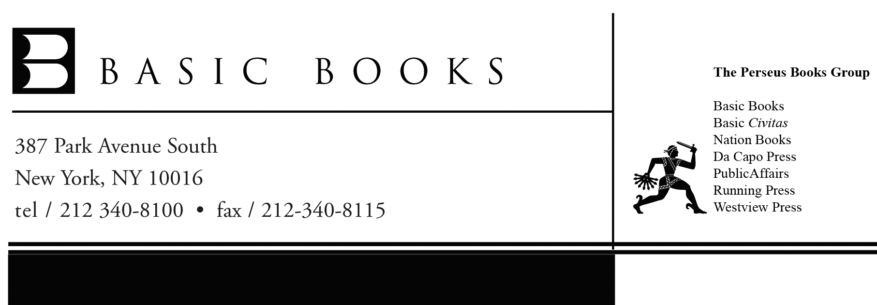

August 2010

Dear Producer/Interviewer:

Most people are familiar with the four dimensions accessible to our everyday senses – the three spatial dimensions and time. But what if there are additional dimensions so small that we haven’t noticed them yet, and in fact, may never seem them directly? And what if, despite their miniscule size, they prove to be crucial to our understanding of the universe – as well as to the actual functioning of the universe – in ways we couldn’t have possibly imagined?

String theory holds that our universe has six more hidden, or “extra,” dimensions that are curled up in elaborate, twisted shapes called Calabi-Yau manifolds. Award-winning mathematician Shing-Tung Yau (who first proved the existence of this strange class of shapes) and science writer Steve Nadis explore what these dimensions mean for our understanding of the cosmos in their new book, THE SHAPE OF INNER SPACE: String Theory and the Geometry of the Universe’s Hidden Dimensions (Basic Books; September 7, 2010).

“Geometry is one of the main avenues available to us for probing the universe,” write Yau and Nadis. “[It] not only deserves a place at the table alongside physics and cosmology, but in many ways it is the table.” In an interview, Yau and Nadis can explain how the Calabi-Yau manifolds first caught the attention of physicists and how they’ve since become vital to string theory and cosmology. They can also discuss topics such as:
- How geometry has been instrumental throughout history in our attempts to make sense of the universe, and why it’s crucial to any understanding of the physical world;
- How the geometry of Calabi-Yau manifolds may hold the key to the most important physical phenomena we know about, including gravity – the force that sculpts our cosmos on the largest scales;
- How different Calabi-Yau shapes – a large if not infinite number of which are possible – might correspond to different universes, coexisting alongside ours;
- What dimensions really are and what a ten-dimensional universe (as posited by string theory) or an eleven-dimensional universe (as posited by the related M-theory) would be like;
- What it would mean for the mathematics of string theory if the physics part of the theory cannot be proved or is just plain wrong.

To arrange an interview with Shing-Tung Yau and/or Steve Nadis, or for additional information or materials, I can be reached at 212-340-8132 or cassie.nelson@perseusbooks.com.

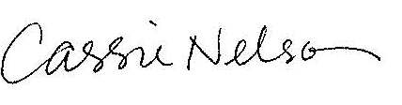
Best wishes,

Cassie Dendurent Nelson
Assistant Director of Publicity

Author tour/speaking schedule for
THE SHAPE OF INNER SPACE:
String Theory and the Geometry of the Universe’s Hidden Dimensions
By Shing-Tung Yau and Steve Nadis
(Basic Books; September 7, 2010)

BOSTON, MA
Friday, September 17, 2010
3:00 PM
Harvard Book Store
1256 Massachusetts Avenue
Cambridge, MA
Shing-Tung Yau and Steve Nadis will discuss the book and answer questions.
Free and open to the public.

BALTIMORE/WASHINGTON, DC
September 24 – 26, 2010
University of Maryland
College Park, MD
Shing-Tung Yau will be available for in-person media interviews
in the Baltimore/Washington, DC area.

# # #

